WEEK-5- REACTJS-HOL
EXERCISE 1:
CODE:
App.js:
- function App() {
- return (
- <div>
- <h1>Welcome to the First Session of React</h1>
- </div>
- );
- }

- export default App;

OUTPUT:

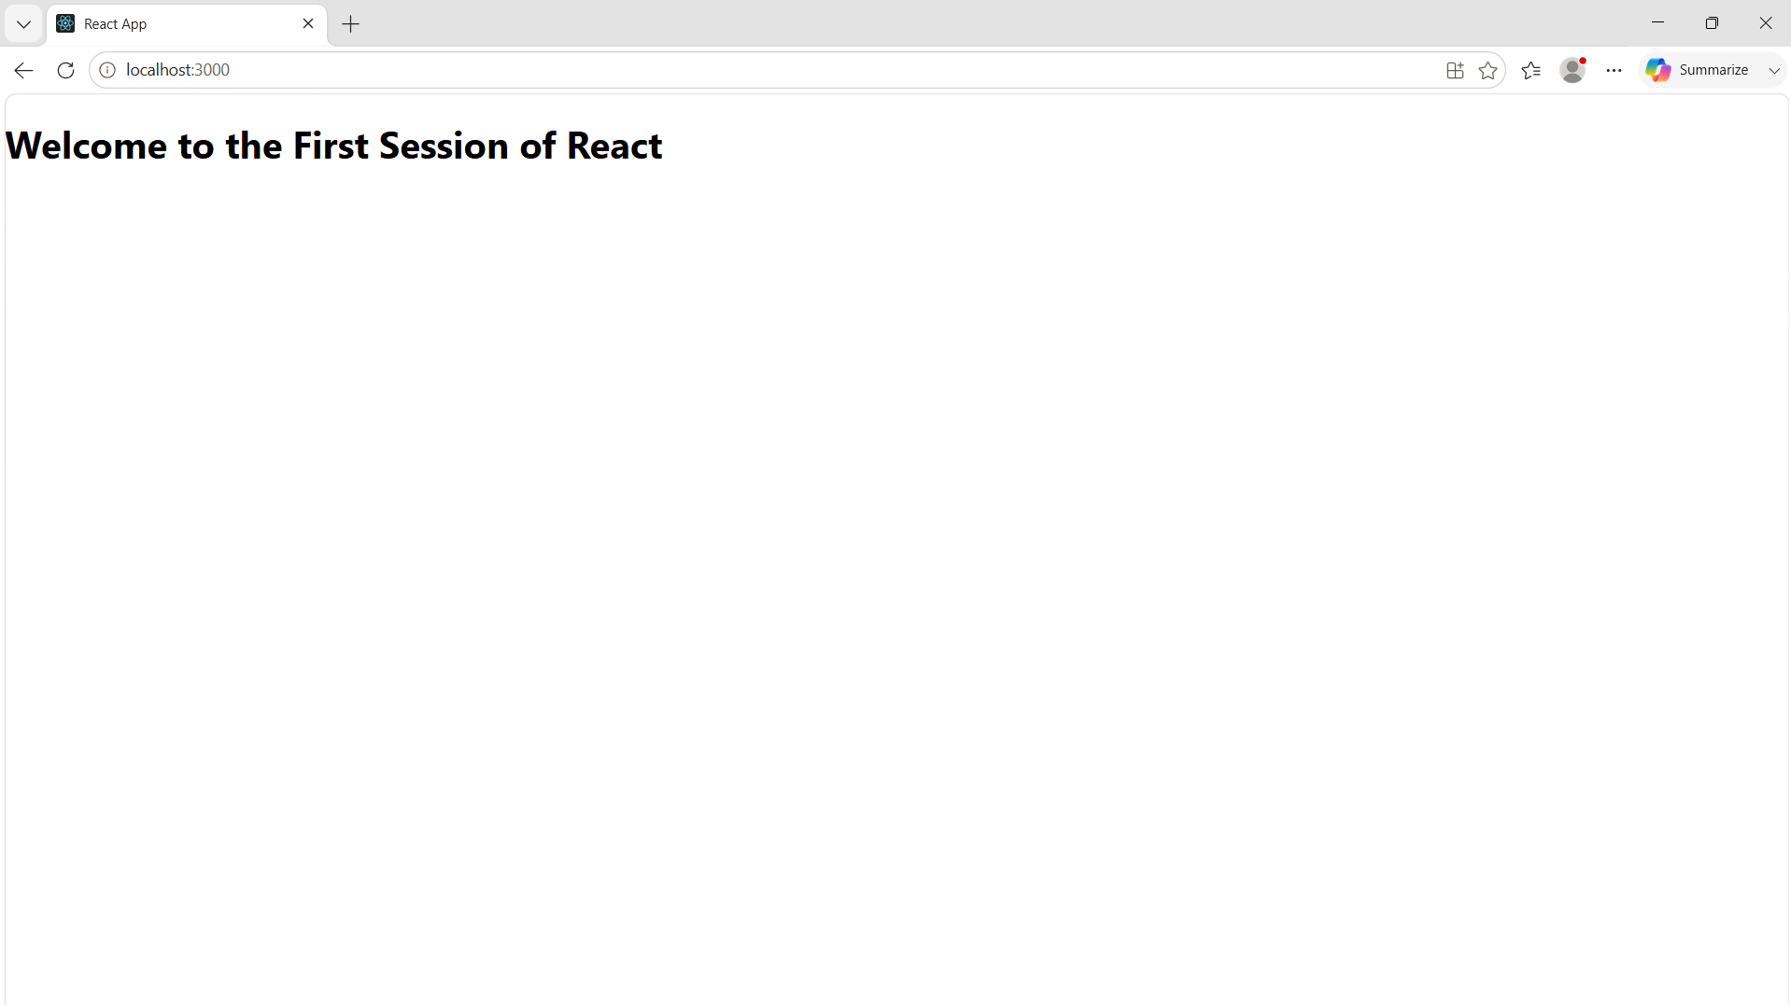

EXERCISE 2:
CODE:
Home.js
import React from "react";

function Home() {
return (
<div>
<h2>Welcome to the Home Page of Student Management Portal</h2>
</div>
);
}

export default Home;

About.js
import React from "react";

function About() {
return (
<div>
<h2>Welcome to the About Page of the Student Management Portal</h2>
</div>
);
}

export default About;

Contact.js
import React from "react";

function Contact() {
return (
<div>
<h2>Welcome to the Contact Page of the Student Management Portal</h2>
</div>
);
}

export default Contact;

App.js
import React from "react";
import Home from "./Components/Home";
import About from "./Components/About";
import Contact from "./Components/Contact";

function App() {
return (
<div>
<Home />
<About />
<Contact />
</div>
);
}

export default App;

Index.js
import React from "react";
import ReactDOM from "react-dom/client";
import App from "./App";

const root = ReactDOM.createRoot(document.getElementById("root"));

root.render(
<React.StrictMode>
<App />
</React.StrictMode>
);

OUTPUT:
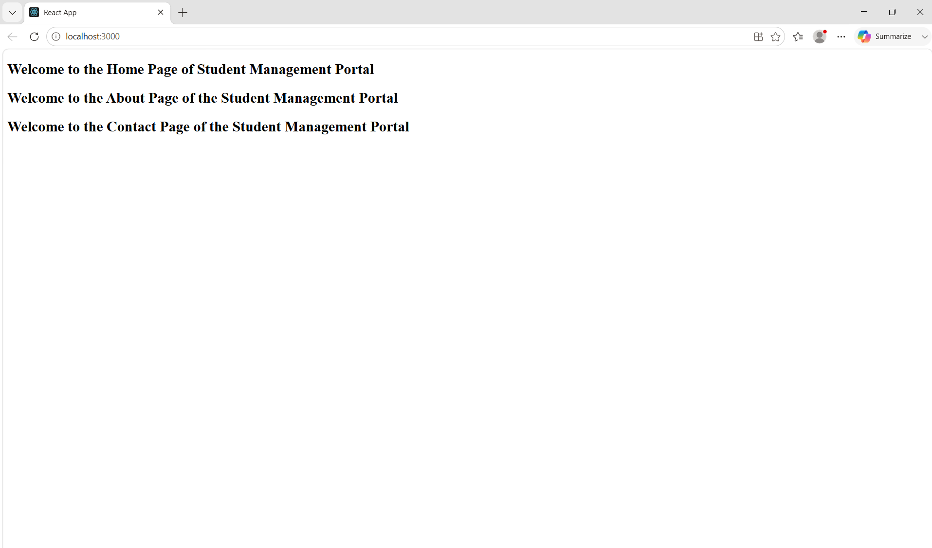

EXERCISE 3:
CODE:
CalculateScore.js:
import React from "react";
import "../Stylesheets/mystyle.css";

function CalculateScore(props) {
const average = props.total / props.goal;

return (
<div className="container">
<h1>Student Management Portal</h1>

<h3>Name: {props.name}</h3>
<h3>School: {props.school}</h3>
<h3>Total Marks: {props.total}</h3>
<h3>Number of Subjects: {props.goal}</h3>

<h2>Average Score: {average}</h2>
</div>
);
}

export default CalculateScore;

CSS File
.container{
width:500px;
margin:40px auto;
padding:20px;
border:2px solid black;
border-radius:10px;
text-align:center;
background-color:#f2f2f2;
}

h1{
color:blue;
}

h2{
color:green;
}

h3{
color:#333;
}

App.js
import React from "react";
import CalculateScore from "./Components/CalculatorScore";

function App() {
return (
<div>
<CalculateScore
name="Shree Harshaa"
school="PSNACET"
total={598}
goal={6}
/>
</div>
);
}

export default App;

index.js
import React from "react";
import ReactDOM from "react-dom/client";
import App from "./App";

const root = ReactDOM.createRoot(document.getElementById("root"));

root.render(
<React.StrictMode>
<App />
</React.StrictMode>
);

OUTPUT:
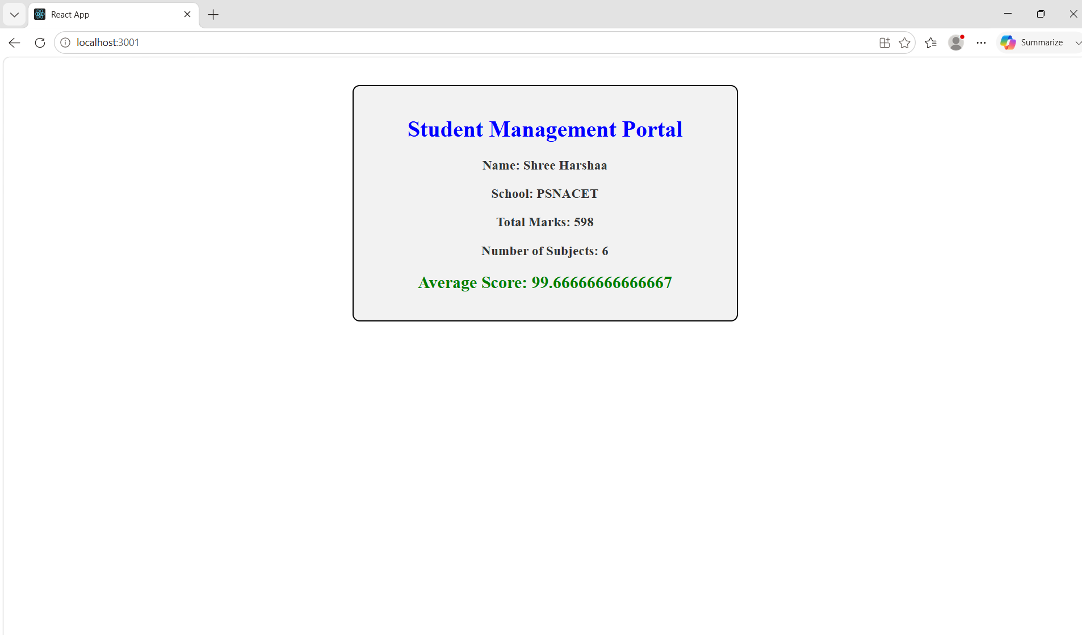

EXERCISE 4:
CODE:
Post.js
class Post {
constructor(id, title, body) {
this.id = id;
this.title = title;
this.body = body;
}
}

export default Post;

Posts.js
import React, { Component } from "react";
import Post from "./Post";

class Posts extends Component {

constructor(props) {
super(props);

this.state = {
posts: []
};
}

loadPosts() {
fetch("https://jsonplaceholder.typicode.com/posts")
.then((response) => response.json())
.then((data) => {
const postList = data.map(
(item) => new Post(item.id, item.title, item.body)
);

this.setState({
posts: postList
});
});
}

componentDidMount() {
this.loadPosts();
}

componentDidCatch(error) {
alert("Error : " + error);
}

render() {
return (
<div>
<h1>Blog Posts</h1>

{this.state.posts.map((post) => (
<div key={post.id}>
<h2>{post.title}</h2>
<p>{post.body}</p>
<hr />
</div>
))}
</div>
);
}
}

export default Posts;

App.js
import React from "react";
import Posts from "./Posts";

function App() {
return (
<div>
<Posts />
</div>
);
}

export default App;

index.js
import React from "react";
import ReactDOM from "react-dom/client";
import App from "./App";

const root = ReactDOM.createRoot(document.getElementById("root"));

root.render(
<React.StrictMode>
<App />
</React.StrictMode>
);

OUTPUT:
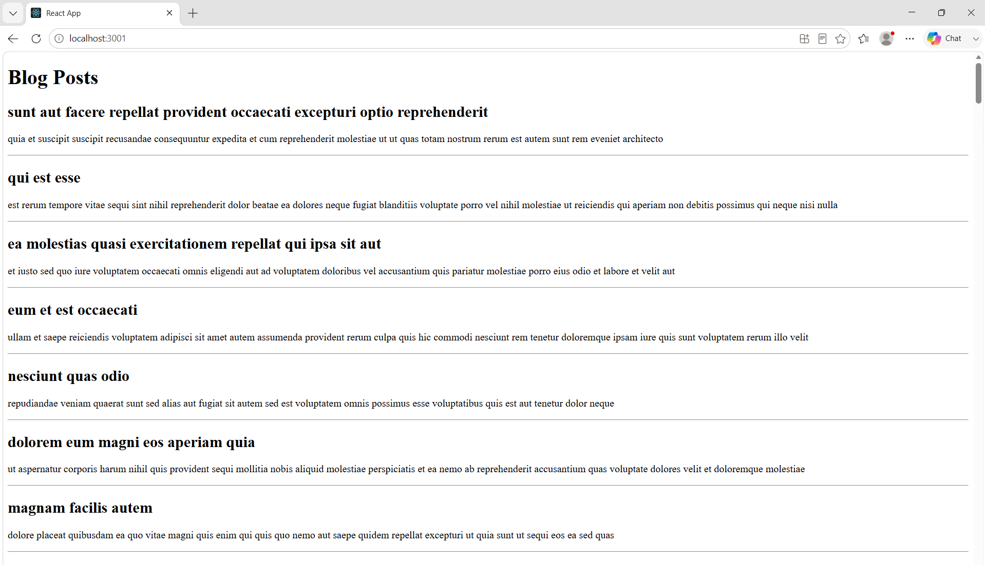

EXERCISE 5:
CODE:
CohortDetails.module.css
.box {
width: 300px;
display: inline-block;
margin: 10px;
padding: 10px 20px;
border: 1px solid black;
border-radius: 10px;
}

dt {
font-weight: 500;
}

CohortDetails.js
import React from "react";
import styles from "./CohortDetails.module.css";

function CohortDetails(props) {

const headingStyle = {
color: props.status === "Ongoing" ? "green" : "blue"
};

return (
<div className={styles.box}>

<h3 style={headingStyle}>
{props.cohortCode} - {props.technology}
</h3>

<dl>
<dt>Started On</dt>
<dd>{props.startDate}</dd>

<dt>Current Status</dt>
<dd>{props.status}</dd>

<dt>Coach</dt>
<dd>{props.coach}</dd>

<dt>Trainer</dt>
<dd>{props.trainer}</dd>
</dl>

</div>
);
}

export default CohortDetails;

App.js
import React from "react";
import CohortDetails from "./CohortDetails";

function App() {
return (
<div>

<h1>Cohorts Details</h1>

<CohortDetails
cohortCode="INTADMDF10"
technology=".NET FSD"
startDate="22-Feb-2022"
status="Scheduled"
coach="Aathma"
trainer="Jojo Jose"
/>

<CohortDetails
cohortCode="ADM21JF014"
technology="Java FSD"
startDate="10-Sep-2021"
status="Ongoing"
coach="Apoorv"
trainer="Elisa Smith"
/>

<CohortDetails
cohortCode="CDBJF21025"
technology="Java FSD"
startDate="24-Dec-2021"
status="Ongoing"
coach="Aathma"
trainer="John Doe"
/>

</div>
);
}
export default App;

OUTPUT:

